**DHA Suffa University**



**Department of Computer Science**

**CS 2001L – Data Structures and Algorithms Lab**

**Fall 2019**

**Lab 05 – Singly Link List**

Objective:

Understand and implement the concepts of singly linked list in C++ using the below operations:

* Insert
* Delete
* Traverse

Linked List:

A linked list is a linear data structure where each element is a separate object. Linked list elements are not stored at contiguous location; the elements are linked using pointers. Each node of a list is made up of two items - the data and a reference to the next node. The last node has a reference to null. The entry point into a linked list is called the head of the list. It should be noted that head is not a separate node, but the reference to the first node. If the list is empty then the head is a null reference.

## **Pros:**

* They are a dynamic in nature which allocates the memory when required.
* Insertion and deletion operations can be easily implemented.
* Stacks and queues can be easily executed.
* Linked List reduces the access time.

**Cons:**

* The memory is wasted as pointers require extra memory for storage.
* No element can be accessed randomly; it has to access each node sequentially.
* Reverse Traversing is difficult in linked list.

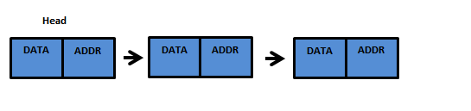

Figure 5.1: Linked List

For creating a node, you can use the following structure to hold the node data structure:

struct node {

int data;

node* next;

};

Singly Linked List

Simply a list is a sequence of data, and linked list is a sequence of data linked with each other.

The formal definition of a single linked list is as follows...

Single linked list is a sequence of elements in which every element has link to its next element in the sequence.

In any single linked list, the individual element is called as "Node". Every "Node" contains two fields, data and next.

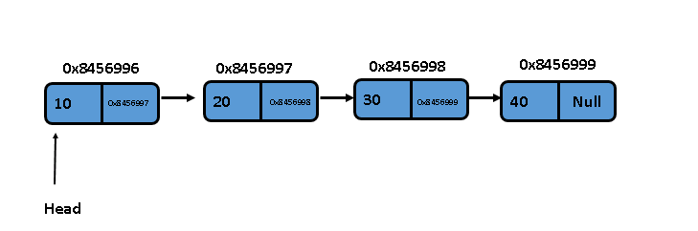

Figure 5.2: Singly Linked List

In a single linked list we perform the following operations...

* Insertion
* Deletion
* Traverse

Insertion

In a single linked list, the insertion operation can be performed in three ways. They are as follows...

* Inserting At End of the list
* Inserting At Beginning of the list
* Inserting At Specific location in the list

|  |
| --- |
| **Algorithm:** InsertAtLast (value)  **Pre:** value is the value to add to the list  **Post:** value has been placed at the end of the list  temp <- Node (value)  if head = NULL  head <- temp  end if  else  Current <- head  loop current.next ≠ NULL  current <- current.next  end loop  current.next <- temp  end else  **end Algorithm:** InsertAtLast (value) |

|  |
| --- |
| **Algorithm:** InsertAtFirst (value)  **Pre:**value is the value to add to the List  **Post:** value has been placed at the  head of the list  temp <- Node (value)  if head = NULL  head <- temp  end if  else  temp.next <- head  head <- temp  end else  **end Algorithm:** InsertAtFirst (value) |

|  |
| --- |
| **Algorithm:** InsertAtPosition (value, position)  **Pre:** value is the value to add to the list position is the position at which the value will be  inserted  **Post:** value has been placed at the specified position of the list  temp <- Node (value)  prev <- Node (NULL)  if head = NULL  head <- temp  end if  else  current <- head  loop i <- 1 to position -1  prev = current  current <- current.next  end loop  if prev = NULL  temp.next <- head  head = temp  end if  else  temp.next <- current.next  current.next<- temp  end else  end else  **end Algorithm**: InsertAtPosition (value, position) |

Deletion

In a single linked list, the deletion operation can be performed in three ways. They are as follows…

* Deleting At Beginning of the list
* Deleting At Specific position in the list
* Deleting At End of the list

|  |
| --- |
| **Algorithm:** DeleteAtFirst ( )  **Pre:** LinkList is already created  **Post:** node deleted from the head of the list  if head = NULL  print “List Empty”  end if  else  temp <- head  head <- head.next  end else  return temp  **end Algorithm:** DeleteAtFirst ( ) |

|  |
| --- |
| **Algorithm:** DeleteAtLast ( )  **Pre:** LinkList is already created  **Post:** node deleted from the end of the list  if head = NULL  print “List Empty”  end if  else  current <- head  loop current.next.next ≠ NULL  current <- current.next  end loop  temp <- current  current.next <- NULL  end else  return temp  **end Algorithm:** DeleteAtLast ( ) |

|  |
| --- |
| **Algorithm:** DeleteNode (value )  **Pre:** value is the value to remove from the list  **Post:** value is removed from the list, true; otherwise false  //Fill by yourself  //Delete a node with a particular value  **end Algorithm:** DeleteNode ( ) |

|  |
| --- |
| **Algorithm:** DeleteAtPosition (position)  **Pre:** position is the position at which the value will be deleted  **Post:** node has been deleted from the specified position of the list  if head = NULL  print “List Empty”  end if  else  current <- head  loop i <- 1 to position -1  current <- current.next  end loop  if current = head  head = current.next  end if  current.next <- current.next.next  end else  **end Algorithm:** DeleteAtPosition (position) |

Traversal in Singly Link list

|  |
| --- |
| **Algorithm:** ForwardTraversal ( )  **Pre:** LinkList is already created  **Post:** the items in the list have been traversed  if head = NULL  print “List Empty”  end if  else  current = head  loop current != NULL  yield current.value  current = current.next  end loop  end else  **end Algorithm:** ForwardTraversal ( ) |

|  |
| --- |
| **Algorithm:** ReverseTraversal ( )  **Pre:** LinkList is already created  **Post:** the items in the list have been traversed  //Fill it on your own  **end Algorithm:** ReverseTraversal ( ) |

**Assignment:**

**Q.1)** Given an input file, write a program to read that file in a singly link list. Each row in a

file is a node, linked to every other node (row) of the file.

1. Sort the linked list on the basis of missing data elements. The node having all data elements comes first, the node missing one data element comes next and so on.

(hint: declare a counter in each node which counts the number of data elements.)

# **Submission Guidelines**

* **Write C++ code , separate function for each operation.**
* **Place your file in a folder named with your rollNo (cs172xxx) where xxx is your 3 digit rollno.**
* **Upload it on LMS.**

**Note:**

**Remember -100 policy for plagiarism.**